British University Team Championships Records
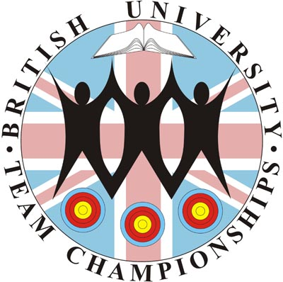

All records are correct up to and including BUTC 2024

Bray I Records

Since the competition began in 2003, the round shot for the ranking round has been a Bray 1 (half of a FITA 18). All scores are recurve.

Team Ranking Round

Team 832 90 42 --- Warwick A 2017

287 30 17 Tom Hall
278 30 15 Sherman Ip
267 30 10 James Jeffs

Individual Ranking Round

Gents 291 30 22 Cheung Sum Hin Sheffield A 2023

Ladies 289 30 21 Jenny Jeppsson Edinburgh A 2008

Novice Individual Ranking Round

Gents 266 30 8 Josh Croall Edinburgh B 2017

Ladies 252 30 5 Dorothee Roger Exeter B 2005

British University Team Championships Records

Hit/Miss Records

From 2007 onwards the format of the knock out round has been four ends of two arrows each at a 60mm hit/miss disc. All scores are recurve.

Team KO Round

20 Oxford A 3rd/4th 2015
Warwick A R16 2017

Match KO Round

33 Oxford A 18 – 15 Loughborough A SF 2014
Edinburgh B 17 – 16 Derby A QF 2017

Team 5 KO Round Total

87 Oxford A (18+16+19+14+20) 2015

Team KO Round – Final

18 Edinburgh A F 2008

Match KO Round – Final

32 Birmingham A 17 – 15 Warwick A F 2017

