University of Derby Archery Club

BUTC 2016

Competition Information Pack

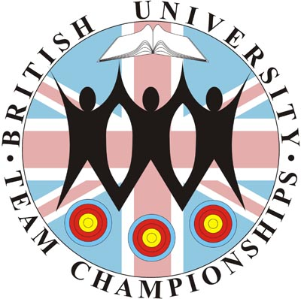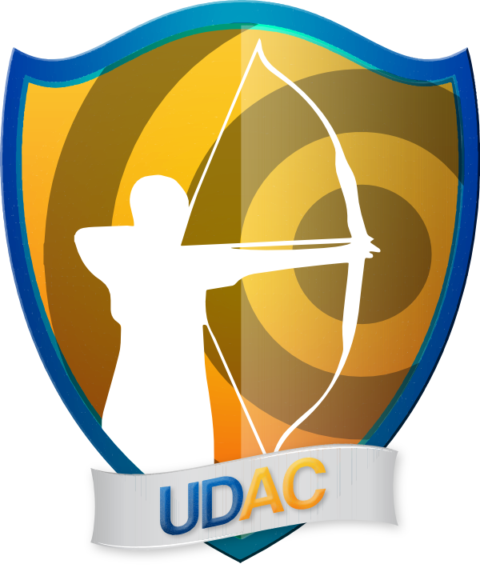

At

University of Derby Sports Centre
Kedleston Road
Derby
DE22 1GB

Saturday 5th March 2016

Sponsored by

Welcome to BUTC 2016 held at UofDAC.

Friday Night Registration

There will be an opportunity for those of you who may be coming to Derby the night before the Competition to register in advance to save time in the morning. The venue for this will be the Jonty Farmer pub. Members of UofDAC will be there from 7.30pm until around 11pm. The location of the Jonty Famer pub is on Kedleston Road, Derby, DE22 1FT, parking is free at the pub.

Venue and Car Parking

The venue for the shoot will be the Derby University Sports Centre. Registration will be open from 8:30am with sighters starting at 10.00am. Parking for cars/minibus will be available in our Main Car park it is numbered 1 and upon arrival to the university drive it is the first right. Parking is free on the weekend. The disabled spaces are in front of the sports centre marked in the picture lease turn left upon arrival to the university drive and use the buzzer to gain access.

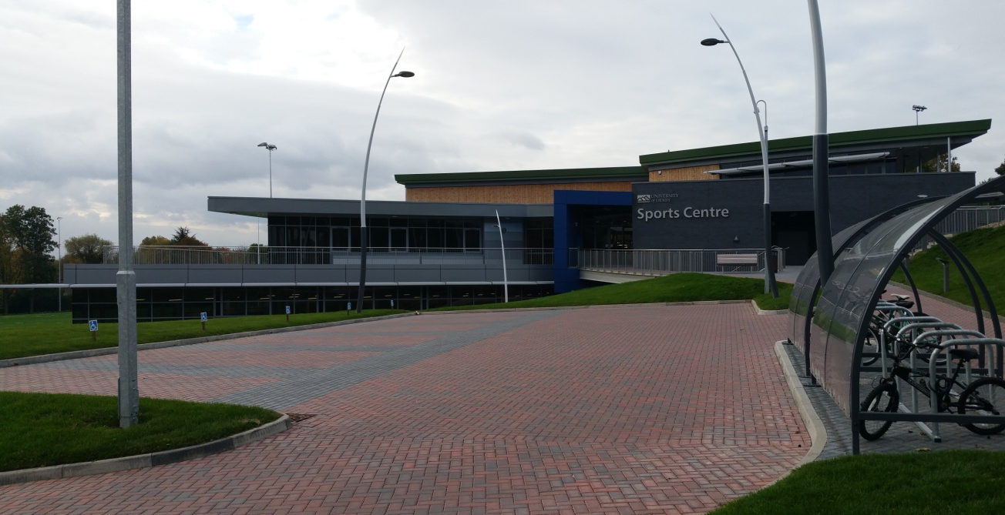
So you can plan your journey, our postcode is: DE22 1GB

Accommodation

Derby has around 16 places for accommodation they vary from £25 up to £70. There is a large mix of 2 Premier Inn's, 2 Travelodge's, 2 Holiday Inn's and numerous other hotels and B&B options. The Holiday Inn Derby – Riverlights and Hampton by Hilton Derby City Centre are both situated next to the bus station that has transport on weekend to Derby University. There is also a large multi-storey car park next door. I have listed the places below all are within 15 miles of Derby University Sports Centre making travel time short.

Days Hotel Derby Premier Inn Derby West Hotel

Holiday Inn Express Derby Pride Park The Coach House B & B

Holiday Inn Derby – Riverlights Travelodge Hotel - Derby Chaddesden

Jurys Inn Derby Green Gables Guest House

Hampton by Hilton Derby City Centre Travelodge Derby Pride Park Hotel

Cathedral Quarter Hotel Thornhill Lodge Guest House

Georgian House Hotel The Greyhound Hotel
Premier Inn Derby South Hotel Victoria Park Hotel

Travel

By Car / Minibus
From the north (M1 - A38)
From the M1/J28, take the A38 south, signposted Derby. At the first major roundabout, continue along the A38 signed Matlock, Ashbourne, Uttoxeter (Outer Ring Road). For Kedleston Road, go all the way round the next roundabout and return north on the A38. Take the first exit, signposted University. Turn left at the top of the slip road and we are on the right.

From the south and west (M1 - A38 - A50)
From the M1/J24, take the A50 signposted Stoke-on-Trent. Leave the A50 at J4 and head north on the A38 towards Derby. Bear left at the next roundabout (A38). From the west, take the eastbound A50 and join the A38 as above. For Kedleston Road, continue straight on at the next roundabout (A38). Take the first exit, sign posted University. Turn left at the top of the slip road and we are on the right.

From the east (Nottingham - A52)
At the end of the A52, continue straight on at the Pentagon roundabout onto the underpass, signposted City Centre (North). For Kedleston Road, bear left, following the signs for A6 Matlock. Once in the one-way system, keep left and follow the signs for Quarndon and Allestree. This will bring you onto Kedleston Road the University is less than a mile, on the right, just after the road crosses the A38.

Parking
Please park in the main car park No.1 at the University, it is the first right as you drive into the University ground. We will have an arrow pointing out where to go. Parking is free.

Parking for disabled archers only
Please take the first left as you drive into the University ground, as there are bays right outside the entrance of the sports centre. Parking is free.

On Site
Directing archery signage will be visible from the main road into parking. We will be in the new sports hall, first building on the left along the University drive.

By Rail
Derby City Centr has a major railway network station; this station is 4 miles away from University of Derby Sports Centre.

By Air

Derby have East Midlands Airport that is 15 miles away from University of Derby Sports Centre. There are regular flights from Aberdeen, Belfast, Edinburgh, Glasgow, Guernsey and Jersey.

By Bus/Coach

National Express coaches run from all major airports and cities in Great Britain to Derby main bus station. There are two bus routes that stop at Derby University and outside the Jonty Farmer pub, one is the Allestree bus that goes from the city, the other bus No.114 stops outside the train station and at bus stop 21 inside the bus station.

Local Amenities

There will be no places to get purchasing food and drink other than a vending machine. There are free water fountains in the building. If the cafe opens we will inform you with what they sell.

Close to the Sports Centre there is Sainsbury Local it is a 20 minutes walk to it. There are two petrol stations on your way to the sports centre one is a Co-op the other is ESSO that has a subway inside and a McDonalds behind.

There is a range of take-away restaurants that will deliver to the Sports Centre and there are a wealth of bars and restaurants in the city serving all kinds of food and drink.

T Shirts

T-Shirts will be available to purchase on the day at a cost of £8 each. We will provide an image of this before entries need to be in and will post this information online.

Contact details

If you have any further questions please feel free to email the UofDAC Tournament Organiser, Glen West, on Archery@udsu.org.uk. For any last minute queries or problems on the weekend please phone either Glen West on 07760 414 941 or Jake Morris (President) on 07846 170 703.

